K.K.Wagh.College of Food Technology,Nashik
1) About Department – Food Plant Operations
The Department of Food Plant Operations focuses on providing practical and technical knowledge related to food processing industries, plant management, equipment handling, production systems, and industrial operations. The department plays an important role in developing skilled food technologists capable of managing modern food processing plants efficiently.
Students gain hands-on experience in food manufacturing processes, plant layout, equipment operation, sanitation, maintenance, quality control, and industrial safety. The department emphasizes practical learning through laboratory work, pilot plant training, industrial visits, and project-based activities.
The department is equipped with modern infrastructure and processing facilities that help students understand real industrial operations in sectors such as dairy, bakery, fruits and vegetable processing, cereals, beverages, and packaging technology.

Key Features of the Department
- Modern food processing laboratories
- Pilot plant operation training
- Industrial exposure and educational visits
- Experienced faculty members
- Practical-oriented learning
- Research and product development activities
- Training in food safety and hygiene practices

Facilities Available
- Food processing equipment
- Packaging and storage units
- Quality testing laboratories
- Computer and internet facilities
- Library with technical journals and books
- Seminar and project facilities

Objectives of the Department
- To provide technical knowledge of food plant operations
- To develop industrial and entrepreneurial skills among students
- To promote research and innovation in food processing
- To prepare students for careers in food industries and allied sectors

- Lab Photos
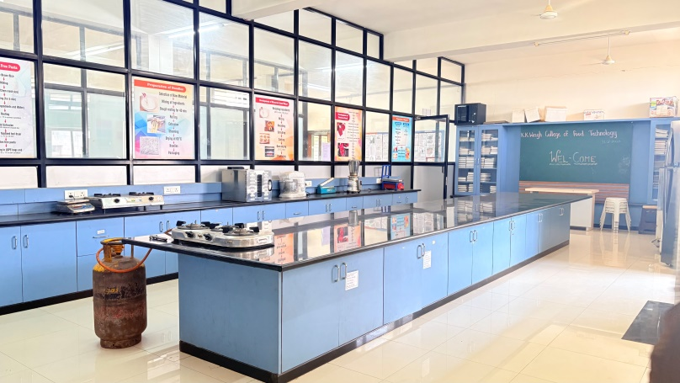
“Food Plant Operation Lab – Practical Learning Experience”

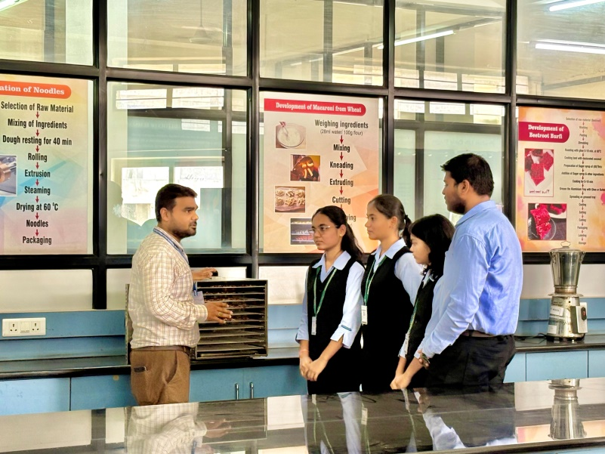
“Demonstration of Food Processing Equipment and Operations”

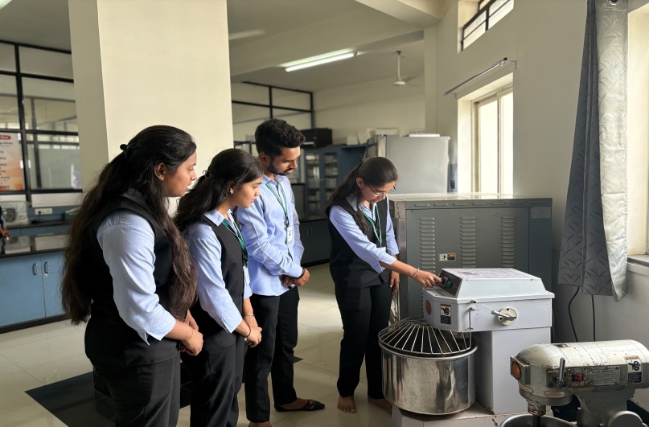

“Students Performing Food Plant Operation Practical”

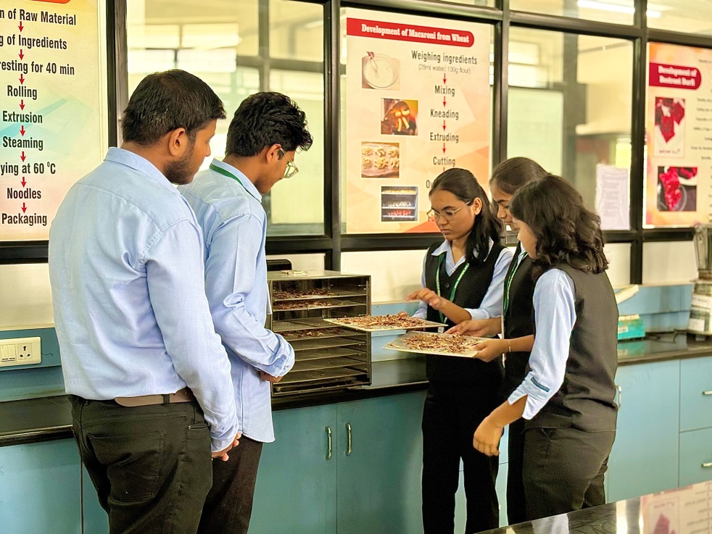
“Practical Exposure in Food Plant Operation Laboratory”

2) Faculty Information

Staff Position

Sr. No | Name of Staff | Qualification | Designation | Date of joining | Photo
1. | Prof. S. S. Bankar | M. Tech.  Food Process Technology | Assistant Professor | 30/10/2022 | 
2. | Ms. T. S. Ingale | Diploma  Food Technology | Lab Assistant | 09/01/2012 | 

3) Infrastructure (Dead-Stock)

Details of Equipment

Sr. No. |  | Name of Equipment | Number | Price of Purchase
1 | Dough Mixer |  | 1 | 25755
2 | Pasta Making Machine |  | 1 | 17141
3 | Fruits and Vegetable Dryer |  | 1 | 51511
4 | Microwave Oven |  | 1 | 21362
1 |  | Prestige Air Fryer | 01 | 13000
1. |  | Refrigerator | 01 | 82010
2. |  | Sealing Machine | 02 | 2300
3. |  | Electronic Weighing Balance 10 kg | 01 | 3000
4. |  | Electronic Weighing Balance | 01 | 3000
5. |  | Jwellery Model | 01 | 7500
6. |  | Fruit Mill | 1 | 4,11,000
7. |  | Fruit Pulper | 1 | 4,11,000
8. |  | Collection Tank | 1 | 4,11,000
9. |  | Kettle | 1 | 4,11,000
10. |  | Semi-automatic pistol filter | 1 | 4,11,000
11. |  | Air compressor | 1 | 4,11,000
12. |  | PVK min Dal Mill Machine | 1 | 82000
13 |  | Wafers Machine | 1 | 120000
14. |  | Noodles & Pasta Maker | 1 | 10600
16. |  | Bread Slicer | 01 | 53000
17.. |  | Baking Oven | 01 | 195000
18. |  | Dough Sheeter | 01 | 210000
19 |  | Normal Display | 01 | 45000
20. |  | Planetary Mixer | 01 | 40000
21. |  | Spiral Mixer | 01 | 131000
22. |  | Bakery Accessories  1. Round Cake Pan 1 kg  2. Round Cake Pan ½ kg  3. Cake Stand  4. palate knife plain  5. Pastry Brush  6. Chopping Board  7. PC Cake Lifter  8. Tart Mould  9. Bread Mould | 12  12  2  6  2  2  1  20  10 | 3300  2700  3600  3570  950  1500  265  1600  2600

Sr. No. | Name of Equipment | Number | Price of Purchase
23 | Alluminium Cake Mould Medium | 02 | 190
24 | Alluminium Cake Mould Big | 04 | 480
25 | Philip hand mixer | 01 | 1995
26 | Gas Batti | 02 | 1940
27 | Mixer (6 liter capacity) | 01 | 13500
28. | Fruit Pulper | 01 | 48830
29 | Juice (Basket) press | 01 | 56800
30 | Nirali S. S. Sinks 27”X2” | 02 | 13,908
31 | Utensils | - | 20432

4) Syllabus

1) Syllabus layout
Sr.no | Semester | Course No | Course Title | Credit Hrs.
1 | 2nd | SEC-123 | Introduction Bottling And Canning line | 2(0+2)
1 | 2nd | SEC-124 | Introduction of Bakery and Manufacturing | 2(0+2)
2 | 4th | SEC-246 | Maintenance of Food Processing Equipment | 2(0+2)
2 | 4th | FPO-241 | Food Plant Utilities And Services | 3(2+1)

Course Title: Introduction to Bottling and Canning Line
Exercise No. | Exercise Title
1–2 | Introduction to bottling and canning process
3 | Study of sorting and grading equipments
4 | Study of washing equipments
5 | Study of peeling methods and equipments
6 | Study of cutting equipments
7 | To perform the blanching of fruits and vegetables
8 | To check the adequacy of blanching process
9–10 | Study of different types of bottles and cans, including materials and sizes
11 | Study of different filling techniques (gravity, pressure, vacuum)
12 | Practical session on filling bottles/cans accurately
13 | Cut out analysis of cans
14 | Hands-on practice on in-bottle sterilization
15 | Hands-on practice with various sealing methods (screw caps, corks, can lids)
16 | Testing seal integrity using various methods
17 | Practical session on labeling machinery operation
18 | Coding and printing best practices for product information
19 | Conduct quality checks on filled and sealed products
20 | Discuss common quality issues and troubleshooting techniques
21 | Study of domestic carbonator and carbonation process
22 | Learn proper cleaning and sanitation protocols for equipment
23–24 | Hands-on cleaning sessions for different parts of the line
25 | Basic maintenance tasks for key equipments
26 | Troubleshooting common problems in bottling and canning lines
27 | Workshop on regulations affecting bottling and canning
28 | Product handling and storage
29 | Practical session on proper storage techniques
30–31 | Study of packaging, labelling and Food Safety and Standards Authority of India regulations of beverages and canned products
32 | Visit to beverage and canning industry

Course Title: Introduction to Manufacturing of Bakery Products
Exercise No. | Exercise Title
1–2 | Introduction and market survey of bakery products
3–4 | Study of different methods of preparation of bakery products (Bread, Biscuit, Cake and Cookies etc.)
5–6 | Determination of gluten content in wheat flour
7–8 | Determination of sedimentation value of wheat flour
9–10 | Determination of Pelshenke value of wheat flour
11–12 | Determination of water and oil absorption of flour
13–14 | Determination of emulsion capacity and stability of flour
15–16 | Determination of foaming capacity and stability of flour
17–18 | Determination of alkaline water retention capacity of flour
19–20 | Preparation and quality evaluation of composite formulation of wheat-based cookies
21–22 | Preparation and quality evaluation of millet-based cookie formulations
23–24 | Preparation and quality evaluation of crackers
25–26 | Preparation and quality evaluation of unleavened flat breads
27–28 | Preparation and quality evaluation of leavened breads (White bread, Brown bread)
29 | Preparation and quality evaluation of cake/muffin
30 | Preparation and quality evaluation of baked cereal bar
31 | Study of packaging, labeling and Food Safety and Standards Authority of India regulations of bakery products
32 | Visit to commercial bakery unit

Course Title: Maintenance of Food Processing Equipment

Exercise No. | Exercise Title
1–2 | Hands on identification of various types of food processing equipment
3–4 | Creation of customized preventive maintenance checklists for different equipment
5–6 | Simulated execution of a preventive maintenance routine
7 | Understanding the types of lubricants used in food processing
8 | Practicing proper lubrication techniques on machinery
9–10 | Learning about different cleaning agents and their appropriate use
11–12 | Conducting cleaning protocols on equipment in compliance with food safety standards
13–14 | Practical exercises in electrical troubleshooting, circuit testing and voltage measurement
15–16 | Dismantling and reassembling parts of common food processing equipment
17–18 | Simulated troubleshooting of common equipment malfunctions
19–20 | Documentation of maintenance activities and preparation of maintenance logs
21 | Study of maintenance of cleaning equipment
22–23 | Study of care and maintenance of Sorting/Grading equipment
24–25 | Study of care and maintenance of Milling equipment
26–27 | Study of care and maintenance of Drying equipment
28–29 | Study of care and maintenance of Material Handling equipment
30–31 | Study of care and maintenance of Packaging equipment
32 | Study of care and maintenance of Storage units

Course Title: Food Plant Utilities and Services

Sr. No. | Topic
1 | Classification of various utilities and services in food plant/industry
2 | Commercial energy pricing
3 | Electrical system: Introduction to electric power supply systems, electrical billing, electrical load management and maximum demand control
4 | Power factor improvement and benefits
5 | Transformers, system distribution losses, harmonics and troubleshooting of electrical power system
6 | Electrical motors: Types, losses in induction motor, motor efficiency and factors affecting motor performance
7 | Rewinding and motor replacement issues
8 | Energy saving opportunities with energy efficient motors
9 | Compressed air system: Requirement, types, compressor efficiency and efficient compressor operation
10 | Compressed air system components, capacity assessment and leakage test
11 | Factors affecting compressed air system performance and efficiency
12 | HVAC and refrigeration system requirements
13 | Vapor compression refrigeration cycle and refrigerants
14 | Coefficient of performance (COP), capacity and factors affecting refrigeration and air conditioning system performance

5) Department Activities Summary
Sr. No | Activity Type | Activity Name | Details
1 | Industrial Visit | Exotic Foods | Students observed food processing operations and industrial management practices
2 | Industrial Visit | Prakash Bakery | Bakery processing, packaging and quality practices study
3 | Industrial Visit | Good Drop Wine | Wine processing and fermentation technology exposure
4 | Student Programme | Ready-to-Eat Product Programme | Hands-on learning on preparation and processing of ready-to-eat food products
5 | Student Programme | Innovative Economic Food Programme | Development of affordable and innovative food products
6 | Expert Visit | Prof. Ajit Jaokar | Interaction and guidance session with students
7 | Expert Visit | Dr. S.G. Deshmukh | Academic discussion and technical guidance
8 | Guest Lecture | Private Sector Opportunities Guidance | Session conducted by Mr. Vinod Raut regarding career opportunities in private food industries
9 | Guest Lecture | Food Laws in Industry | Lecture delivered by Miss Nita Nair on food laws and regulations in industries

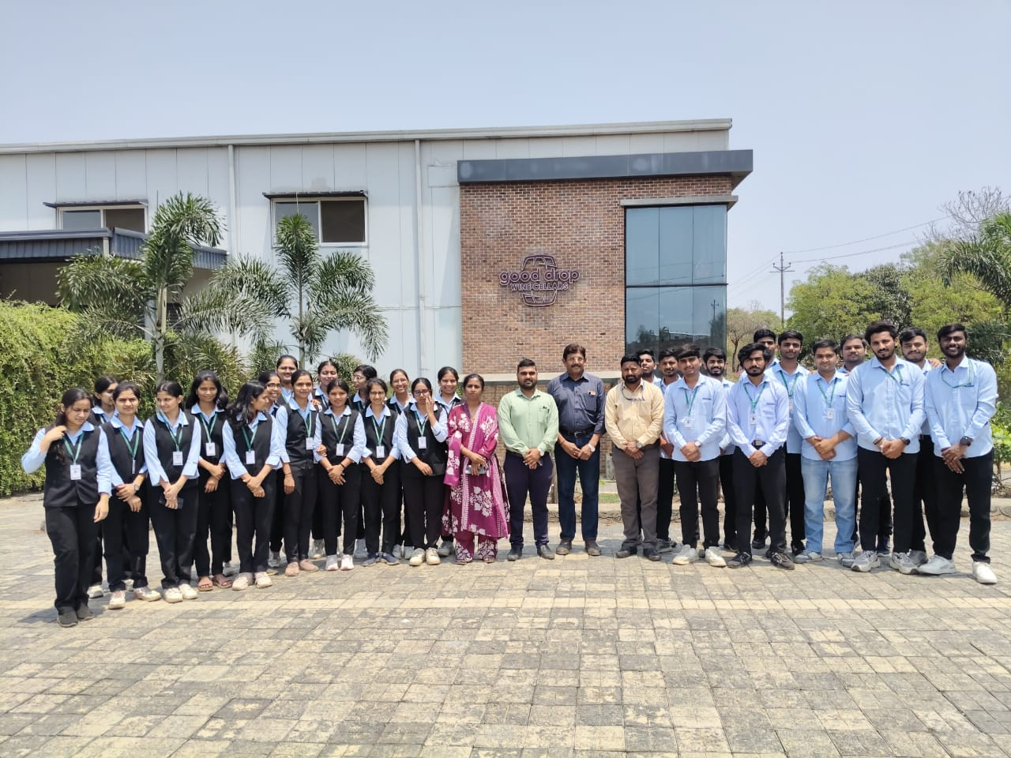
Industrial Visit Good Drop Wine

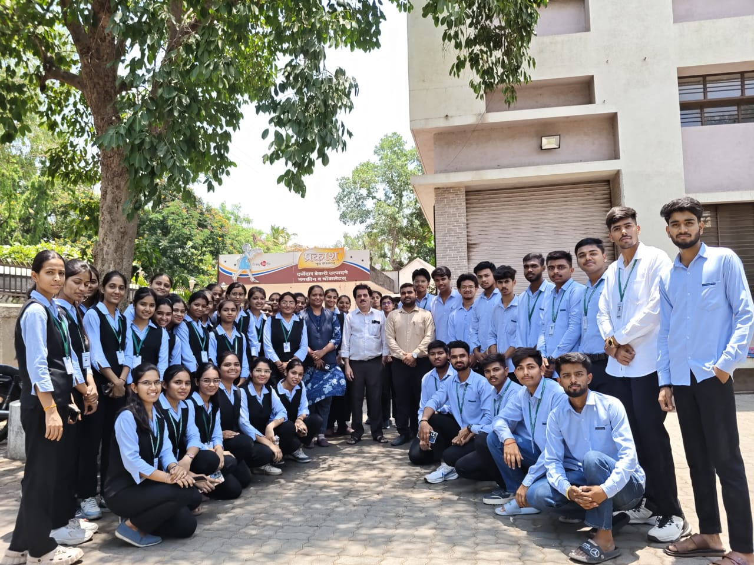

Industrial Visit Prakash Bakery

6) Photo Gallery

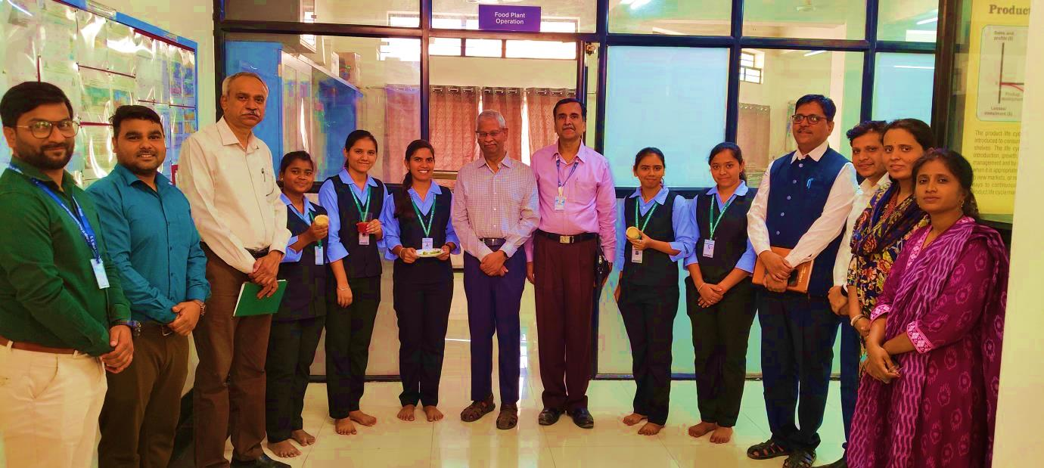
Dr. S. G. Deshmukh graciously visited K. K. Wagh College of Food Technology and thoroughly evaluated our food products.

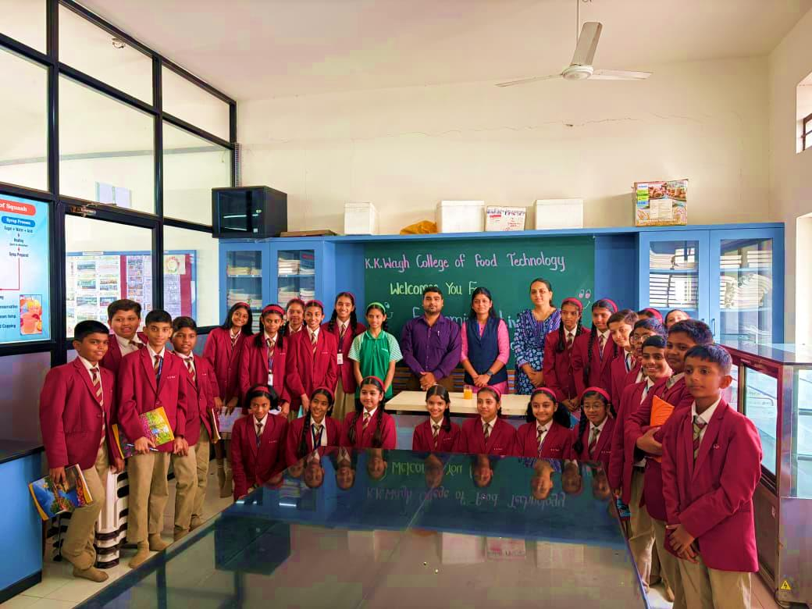
K. K. Wagh College of Food Technology, Nashik organized a programme on Economic Activities in the Food Sector for school students from D.G.P. Nagar, Nashik.”

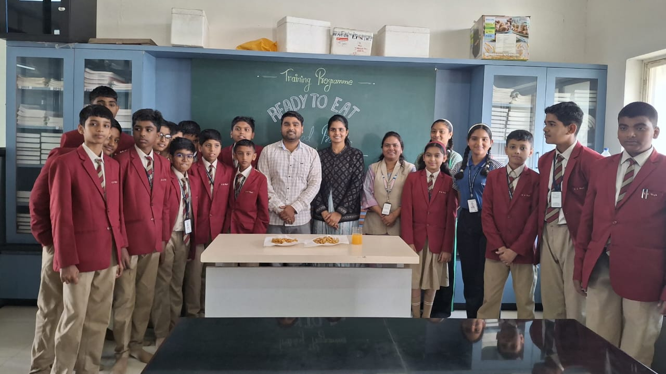
*Training Program on Ready-to-Eat (RTE) Food Products*

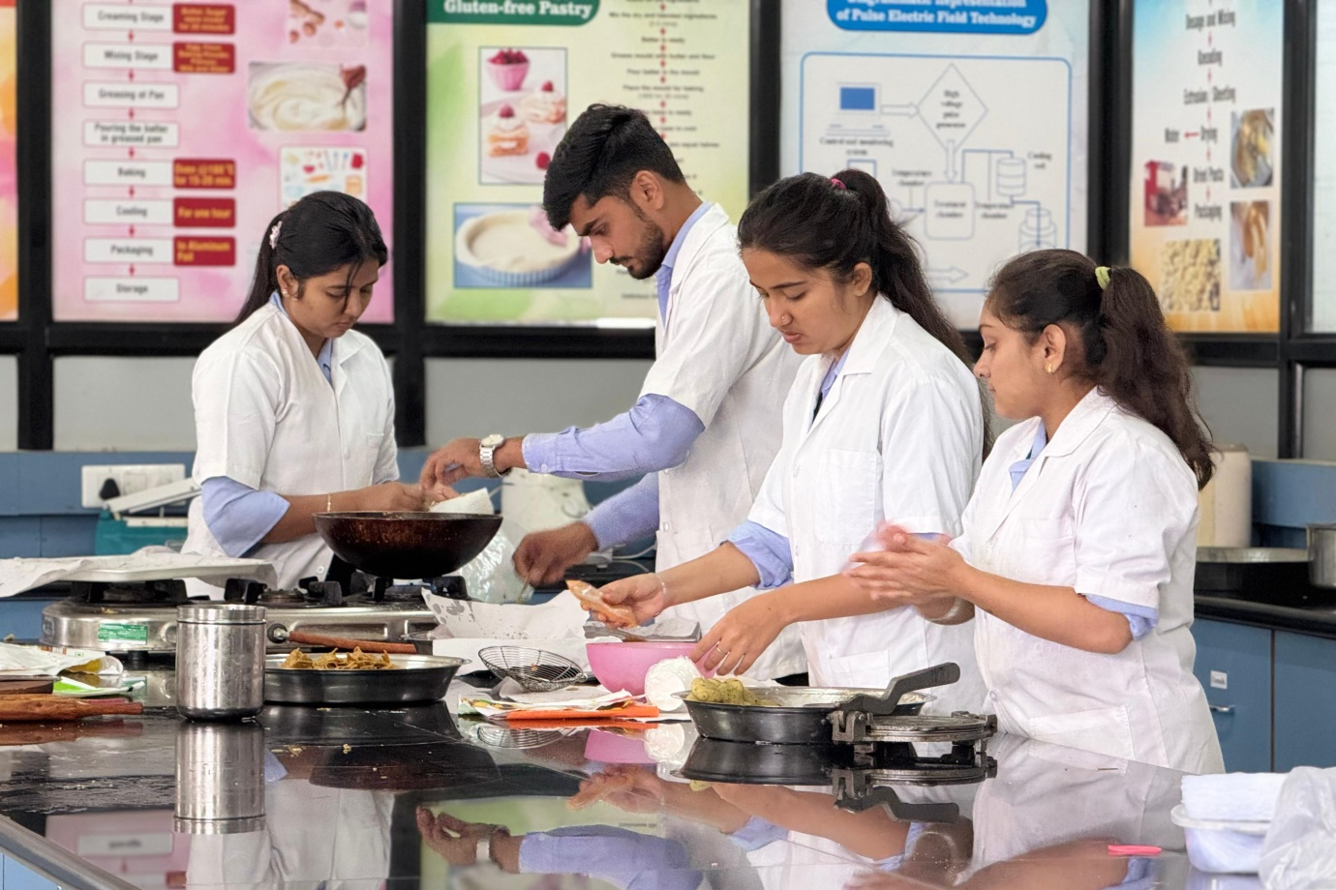
ELP Students Working in Lab

